**A PROJECT REPORT ON**

“APPs IN MYANMAR”

FOR

Company Name

GEO MANDALAR Co.ltd

**Director**

U Ravi Chhabra

**Supervisor**

Daw Ank Phyu Win

**SUBMITTED BY**

Ma Khin Su Myat Noe

Ma Su Po Po

Mg Han Htun Aung

Mg Kaung Myat Thu

Ma Hla Yamin Htike

Ma Hnin Yu Aung

**University of Computer Studies (Mandalay)**

**Date**

**Group Members**

|  |  |  |  |
| --- | --- | --- | --- |
| **Roll No** | **Name** | **Signature** | **Date** |
| 5CS-25 | Ma Khin Su Myat Noe |  |  |
| 5CS-26 | Ma Su Po Po |  |  |
| 5CS-27 | Mg Han Htun Aung |  |  |
| 5CS-28 | Mg Kaung Myat Thu |  |  |
| 5CS-29 | Ma Hla Yamin Htike |  |  |
| 5CS-30 | Ma Hnin Yu Aung |  |  |

**(Project Supervisor Name) Signature/ Date**

Daw Ank Phyu Win

**CONTENTS**

**Page Number**

**Abstract**

**Acknowledgement**

**Declaration**

**List of Figures**

**CHAPTER 1 INTODUCTION**

* 1. **Introduction**
  2. **Background** 
     1. **What is Git?**
     2. **What is Github?**
     3. **What is Github page?**
     4. **What is Firebase?**
  3. **Objective of the project**

**CHAPTER 2 PROJECT DEVELOPMENT**

**2.1 Design**

**2.1.1 Flow Chart Diagram**

**2.1.2 Use Case Diagram**

**2.1.3 Sequence Diagram**

**CHAPTER 3 EVALUATION AND CONCLUSIO**

**3.1 Conclusion**

**3.2 Advantages of the project**

**3.3 Disadvantages of the project**

**Abstract**

This project shows of top applications in Myanmar. All users can easily search desired applications in Myanmar. It also describes the latest version of the application. Admin can insert new data, update data, delete data and view data. By using this system, the user can easily search within short duration we hope that will be useful for the user more easily. The project is implemented by HTML, CSS, JAVASCRIPT, and PYTHON programming languages.

**Acknowledgement**

First, We would like to thankful greatly following persons who have contributed directly or indirectly towards the success of this project.

We would like to respectfully thank U Kyaw Swar Soe, Rector of Computer University (Mandalay), for his kind permission to carry out this project, general guidance and workable environment during the period of study.

We would like to express our Director, U Ravi Chhabra, Director our Geo-Delta-MDY group, for his guide way to create our project with successfully and nicely.

We also wish to express our supervisor, Daw Ank Phyu Win, Lecturer of faculty of Computing , Computer University (Mandalay), for her helpful advice, helpful encouragement numerous invaluable suggestion and comments.

We also great full to all out teachers for Computer University

( Mandalay ) who have taught and guided us during the period of study. Finally, we are thankful to our follow members who work together in this project and we also thanks again for the unity.

**Declaration**

We declare that this project report or part of it was not a copy of document done by any organization university any other institute or a previous student project group at Computer University (Mandalay) and was not copied from the Internet or other resources. We understand. That Plagiarism is an academic offence and if we are found to have committed or abetted the offence of plagiarism in relation to this submitted work, disciplinary action will be enforced.

**Project Details**

|  |  |
| --- | --- |
| **Project Title** | **Apps in Myanmar** |
| **Project ID** | **Geo-Mandalar Company Internship** |

**Chapter 1**

**Introduction**

* 1. **Introduction**

Nowadays, everybody can use personal computer in their own life. As the improving of the network technology, people use computer with the internet. To save time and to reduce people’s physical effort, internet technology is more important in current people life. To help the past of the improving internet, we create “Apps in Myanmar” application to find information easily in second.

The project provides us the complete and accurate information about apps in Myanmar. These applications can perform with wireless.

The project “Apps in Myanmar” is aimed to find apps information in Myanmar. The project is developed in HTML, CSS, PYTHON, JAVA SCRIPT for window side. Our project mainly focuses on finding apps information in Myanmar without working time. To reduce users time and physical efforts, users can search any apps information in Myanmar with a little moment in their own personal computer rooms. Our project is very useful for those who want to save their time and don’t want to take manually efforts.

* 1. Background of the system

**Introduction to Git, GitHub, and GitHub Pages**

Git, GitHub, and GitHub Pages are all very closely related. Imagine Git as the workflow to get things done and GitHub and GitHub Pages as places to store the work you finish. Projects that use Git are stored publicly in GitHub and GitHub Pages, so in a very generalized way, Git is what you do locally on your own computer and GitHub is the place where all this gets stored publicly on a server.

**1.2.1 What is Git?**

Git is a version control system that tracks changes to files in a project over time. It typically records what the changes were (what was added? what was removed from the file?), who made the changes, notes and comments about the changes by the changer, and at what time the changes were made.

Git is for people who want to maintain multiple versions of their files in an efficient manner and travel back in time to visit different versions without juggling numerous files along with their confusing names stored at different locations.

In the diagram below, each stage represents a “save”. Without Git, you cannot go back to any of the in between stages from the initial draft and final draft. If you wanted to change the opening paragraph in the final draft, you’d have to delete data that you couldn’t recover. To work around this, we use the “save as” option, name it something different, delete the opening paragraph and start writing a new one.

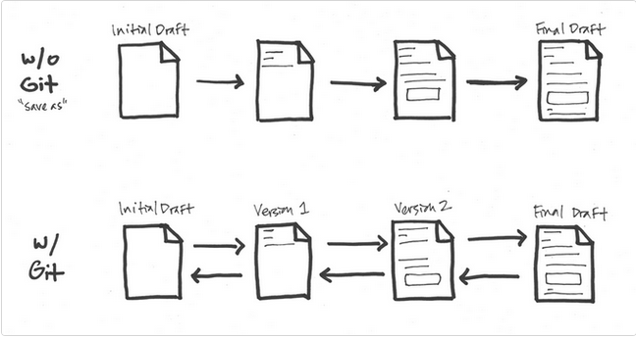

With Git, the flow is multidirectional. Each change that is significant is marked as important in a version, and you proceed. If you need to get back to earlier stages, you can without any loss of data. Presently, Google Docs “revision history” or Wikipedia’s “edit history” work in this sort of fashion. Git is just a lot more detailed and can get a lot more complex if needed. 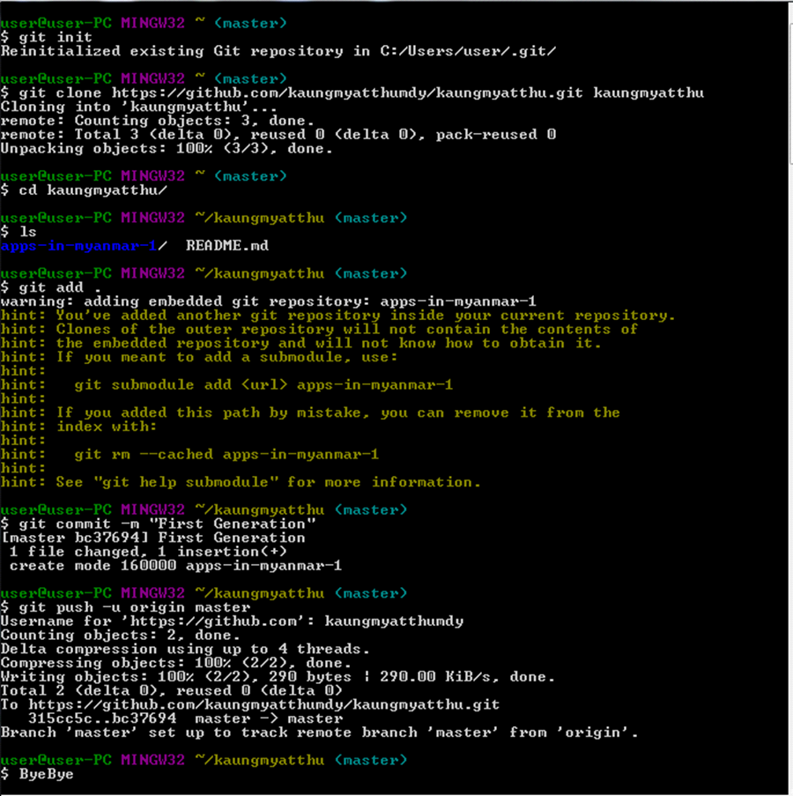

**1.2.2 What is GitHub?**

GitHub is a web hosting service for the source code of software and web development projects (or other text based projects) that use Git. In many cases, most of the code is publicly available, enabling developers to easily investigate, collaborate, download, use, improve, and remix that code. The container for the code of a specific project is called a repository.

GitHub is a code hosting platform for version control and collaboration. It lets you and others work together on projects from anywhere.

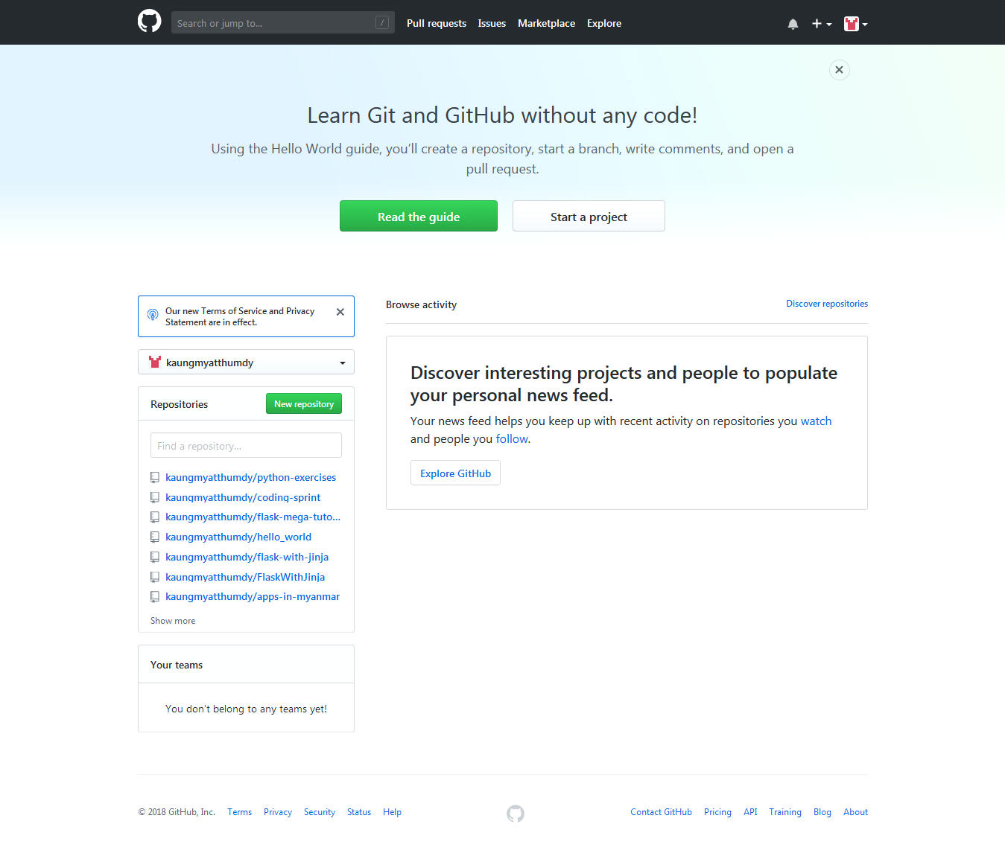

**What are the benefits of GitHub? (OR) What are the main benefits of using GitHub?**

It makes it easy to contribute to your open source projects. To be honest, nearly every open-source project uses GitHub to manage their project.

1. It makes it easy to contribute to your open source projects

2. Documentation.

3. Showcase your work. ...

4. Markdown. Markdown allows you to use a simple text editor to write formatted documents.

5. GitHub is a repository. ...

6. Track changes in your code across versions. ...

7. Integration options.

Understanding the GitHub Flow

Link:

<https://guides.github.com/introduction/flow/>

**1.2.3 What is GitHub Page**

GitHub Pages are public webpages hosted for free through GitHub. GitHub users can create and host both personal websites (one allowed per user) and websites related to specific GitHub projects. Pages let you do the same things as GitHub, but if the repository is named a certain way and files inside it are HTML or Markdown, you can view the file like any other website. GitHub Pages is the self-aware version of GitHub. Pages also come with a powerful static site generator called Jekyll.

GitHub Pages is a static site hosting service designed to host your personal, organization, or project pages directly from a GitHub repository and doesn't support server-side code such as, PHP, Ruby, or Python.

You can create and publish GitHub Pages sites online using the Jekyll Theme Chooser. Or if you prefer to work locally, you can use GitHub Desktop or the command line.

**User, Organization, and Project Pages**

There are two basic types of GitHub Pages sites: Project Pages sites, and User and Organization Pages sites. They are nearly identical but have some important differences.

Project Pages sites are connected to a specific project, and the site files live on a branch within the project repository.

User and Organization Pages sites are not tied to a specific project, and the site files live in a special repository dedicated to GitHub Pages files.

**Building our own site from scratch or generate one for our project.**



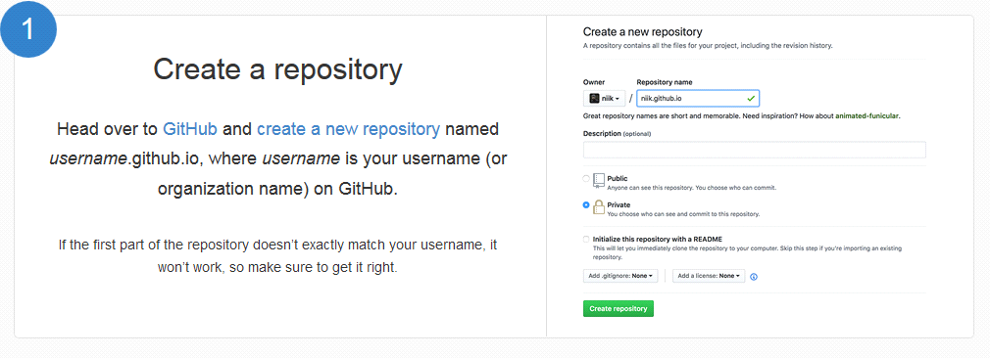



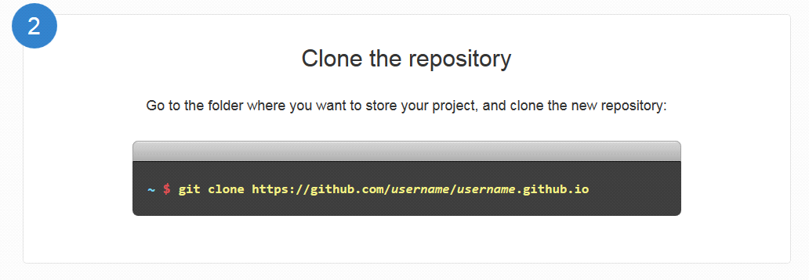

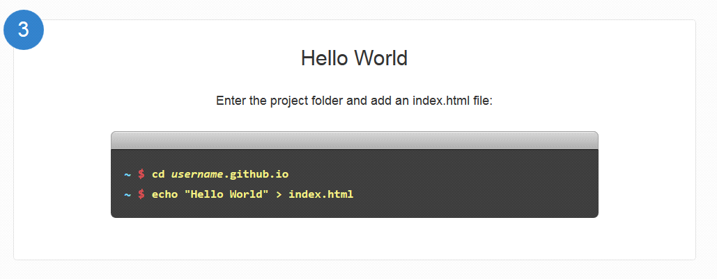

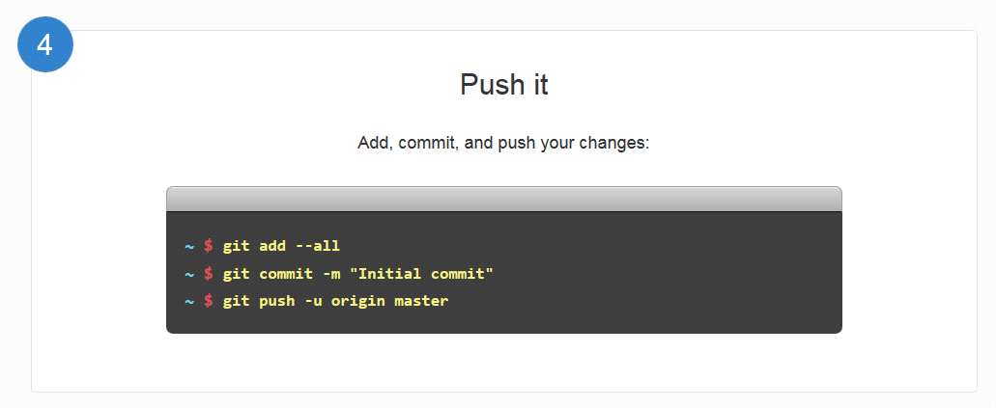

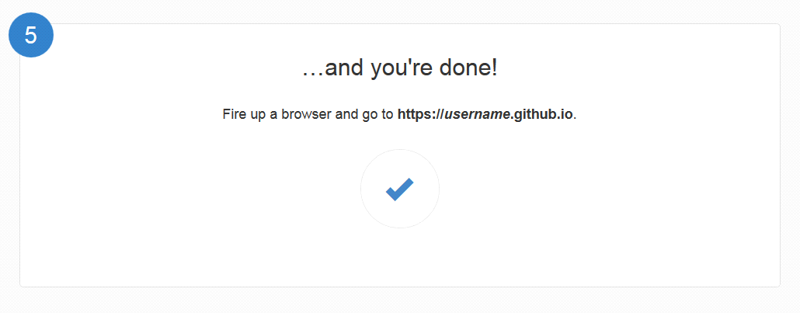

For example

<https://kaungmyatthumdy.github.io>

<https://Mohninyu.github.io>

<https://hlayaminhtike.github.io>

<https://khinhsumyatnoe.github.io>

<https://SuPoPoo.github.io>

<https://hanhtunaung.github.io>



**1.2.4 Firebase**

Firebase Hosting is a static and dynamic web hosting service that launched on May 13, 2014. It supports hosting static files such as CSS, HTML, JavaScript, and other files as well as dynamic Note.js support through Cloud function.

Real time database, Storage , Authentication future for your user, you can also use cloud function for complicated logics in your app. Firebase is a back-end service that your app can interact with. It has a lot of features such as Real time database, User Authentication, file storage and much more.

Firebase provides a realtime database and backend as a service. The service provides application develops an API that allows application data to be synchronized across clients and stored on Firebase’s cloud.

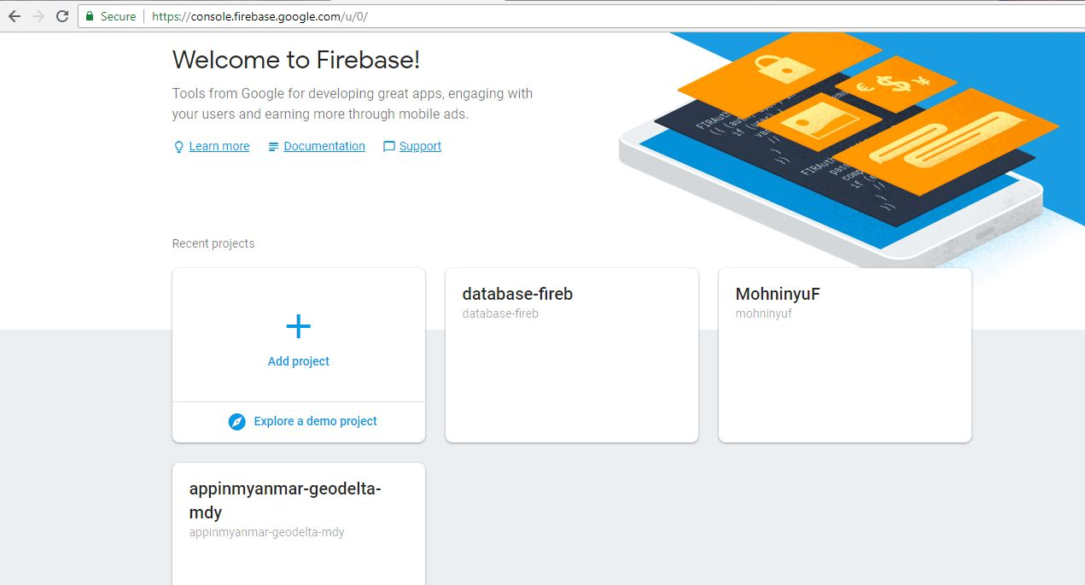

**Examples for Firebase**

**By using real-time database**

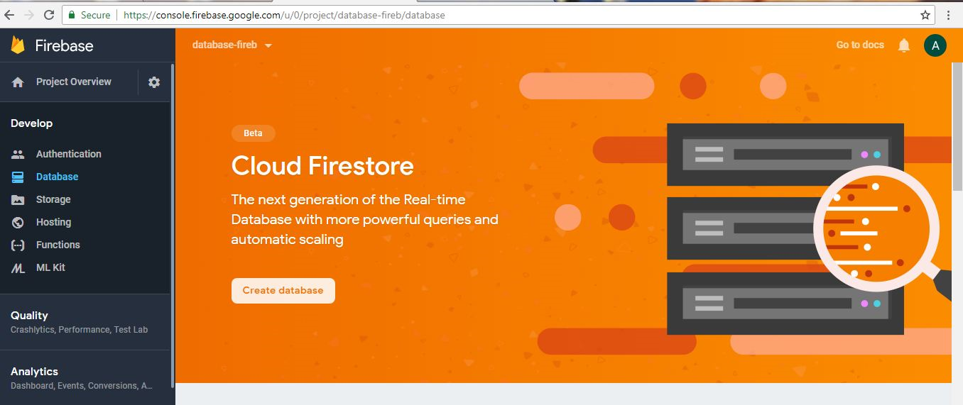

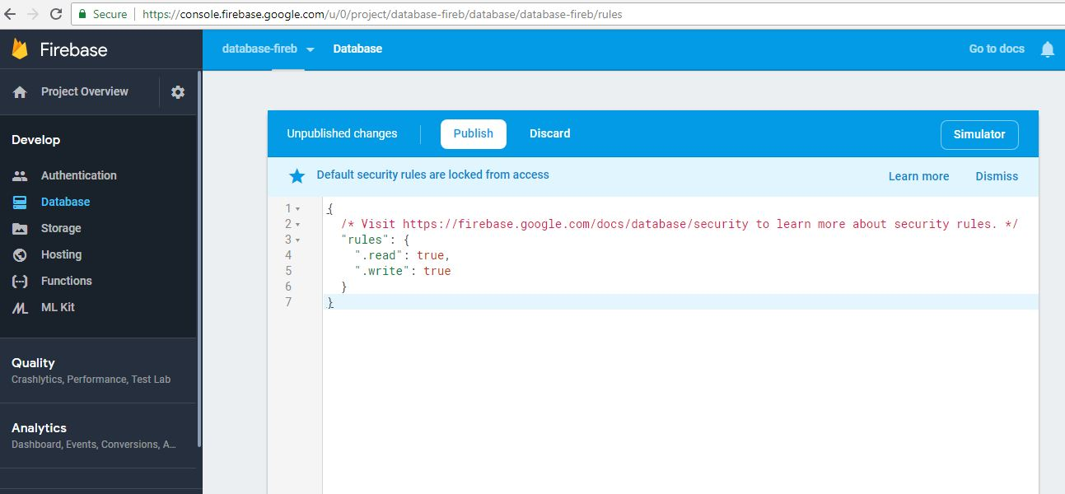

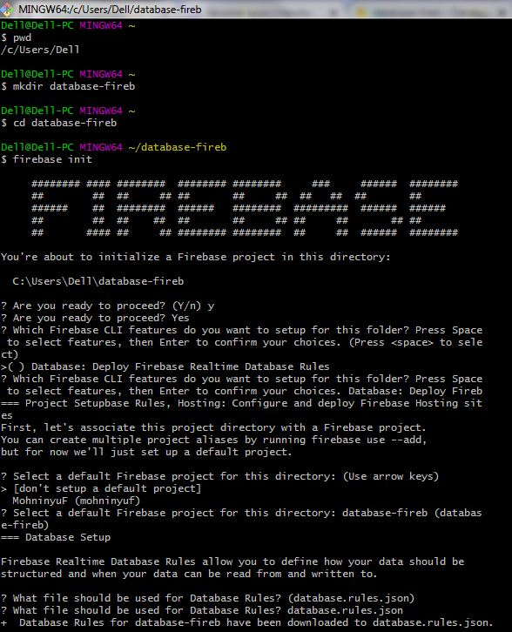

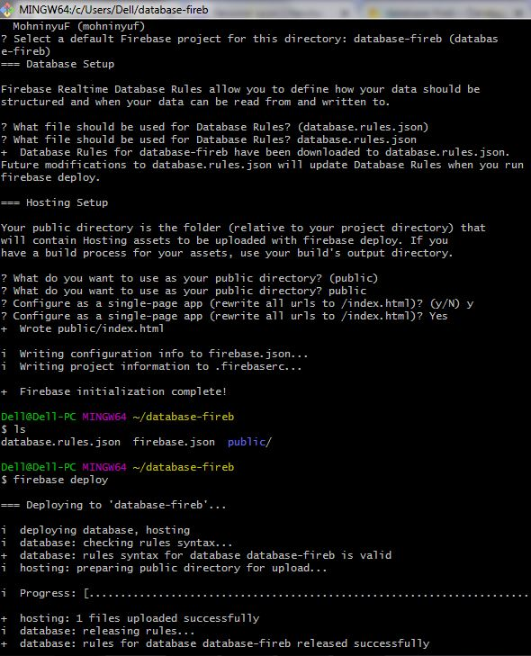

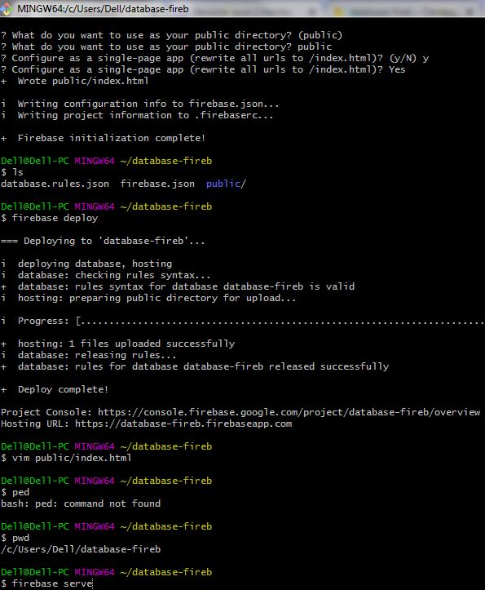

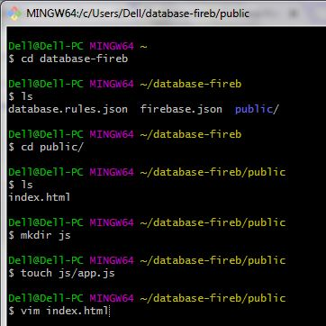

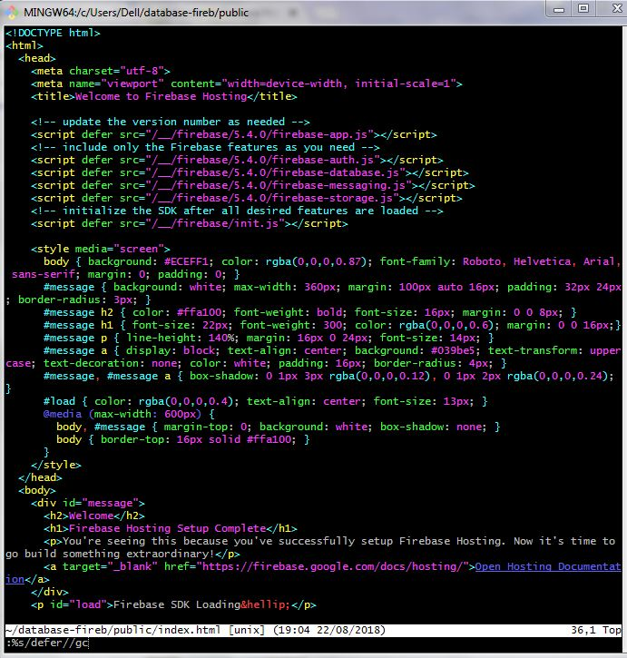

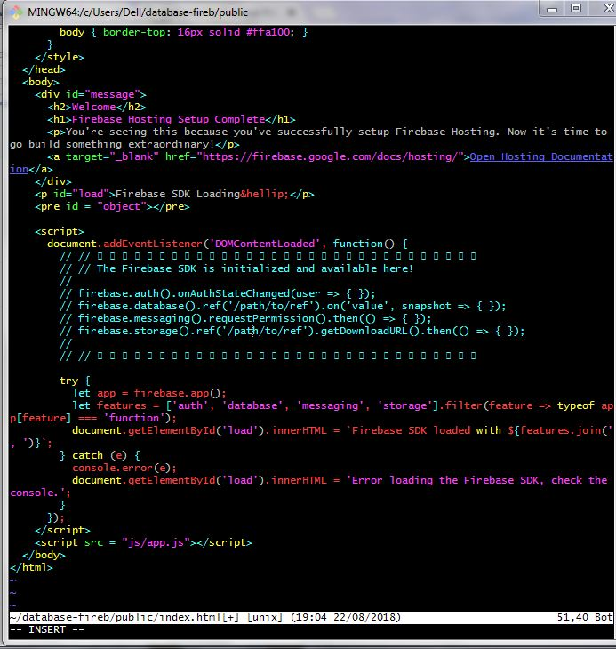

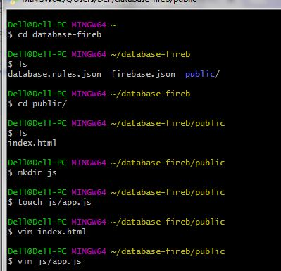

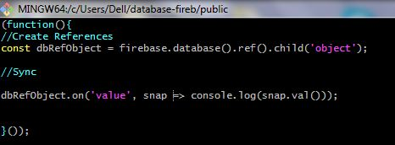

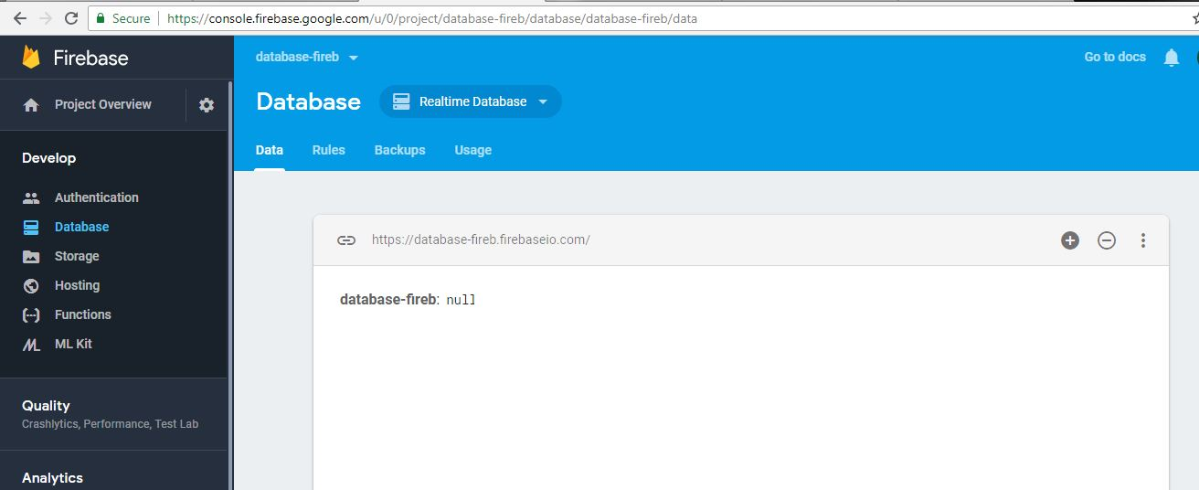

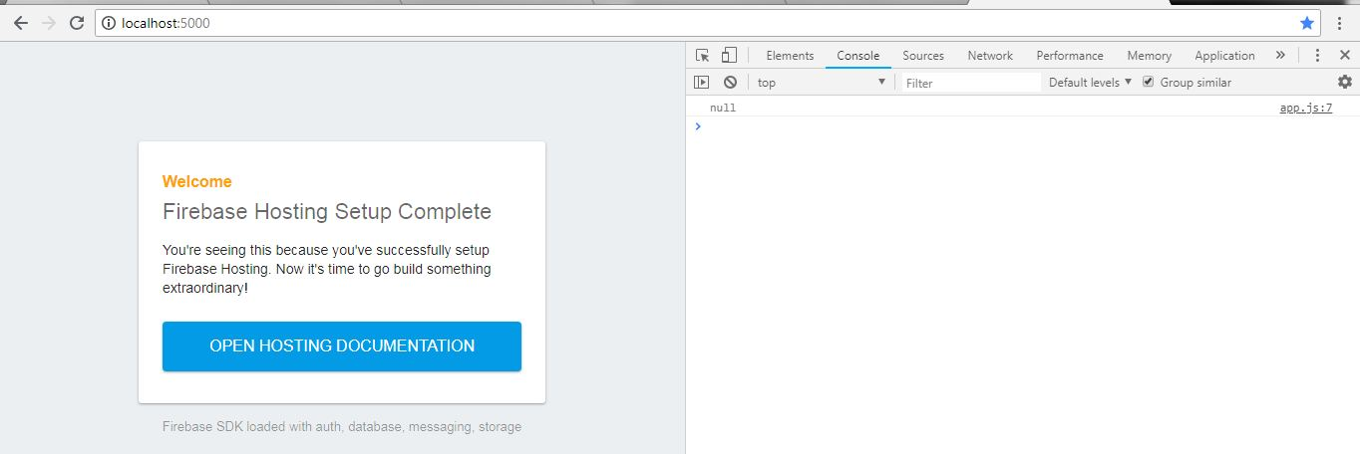

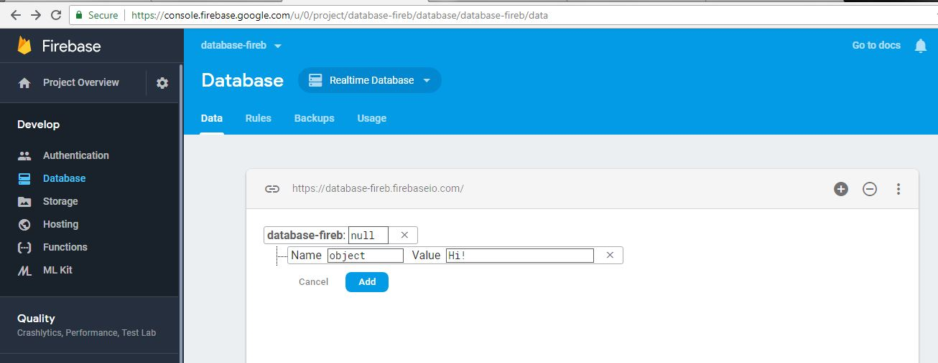

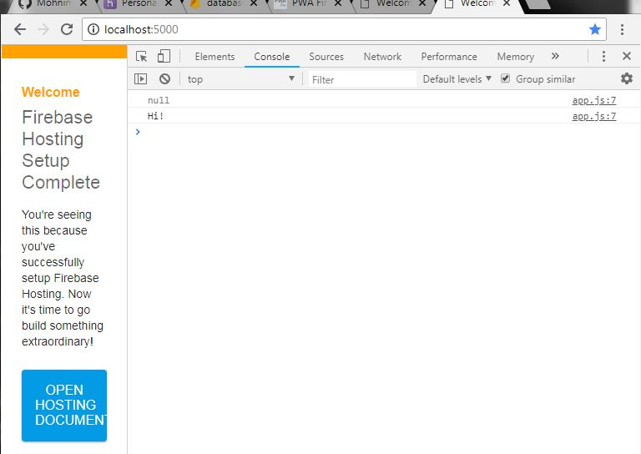

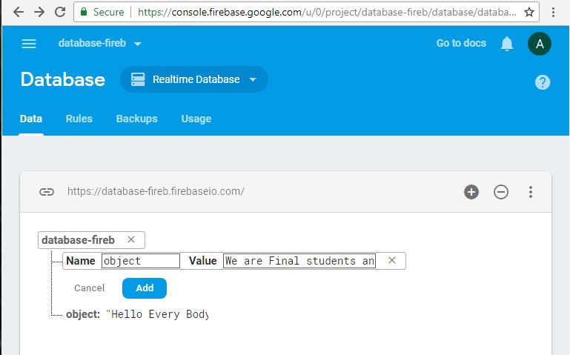

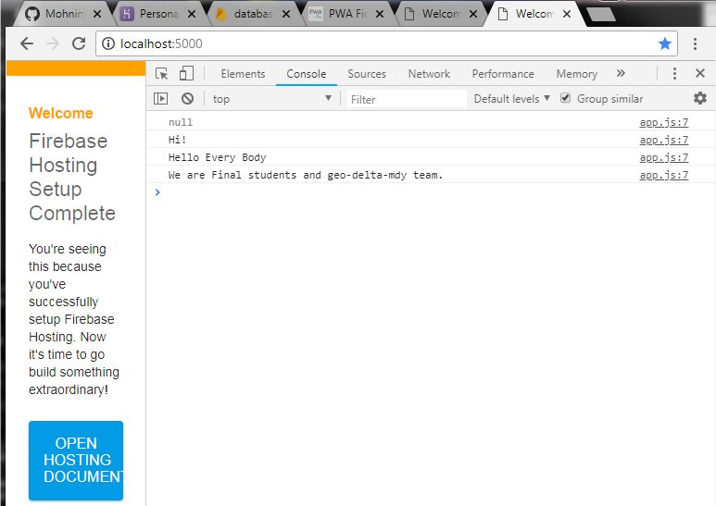

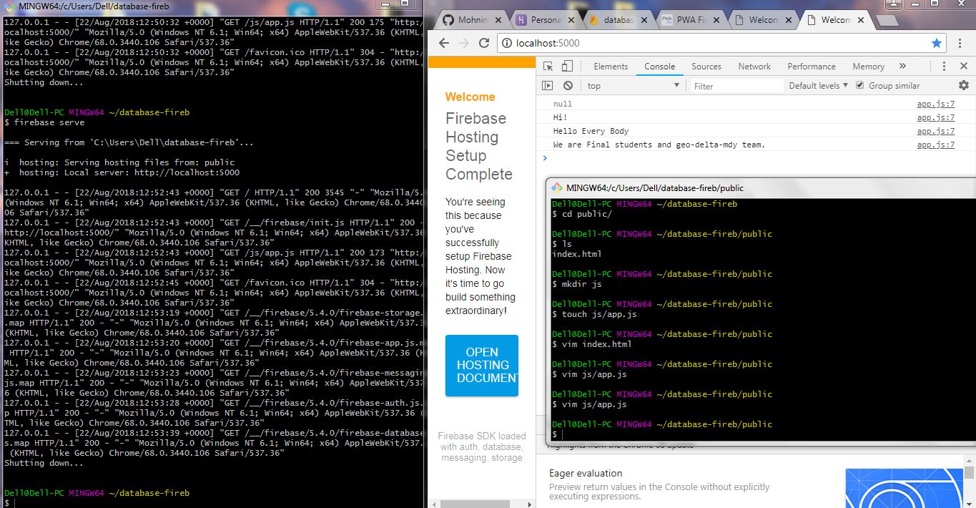

**Example for Firebase**

**By using Authentication**

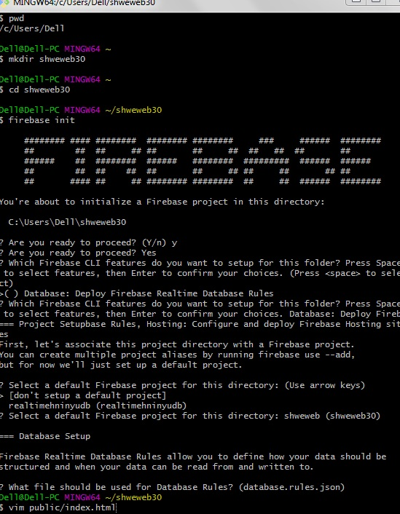

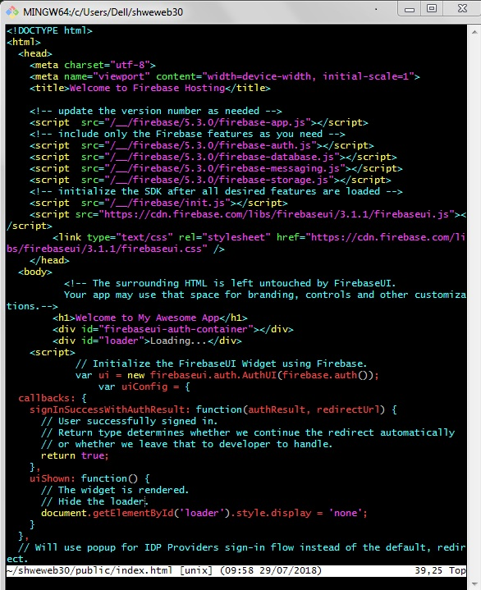

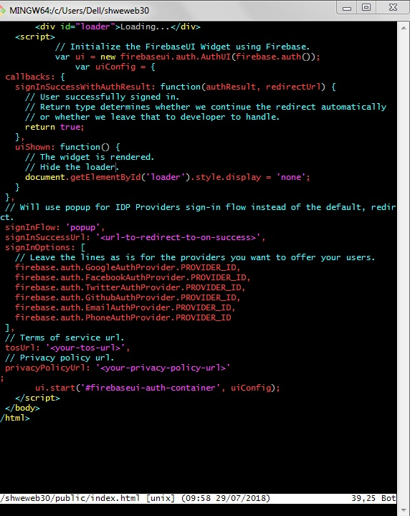

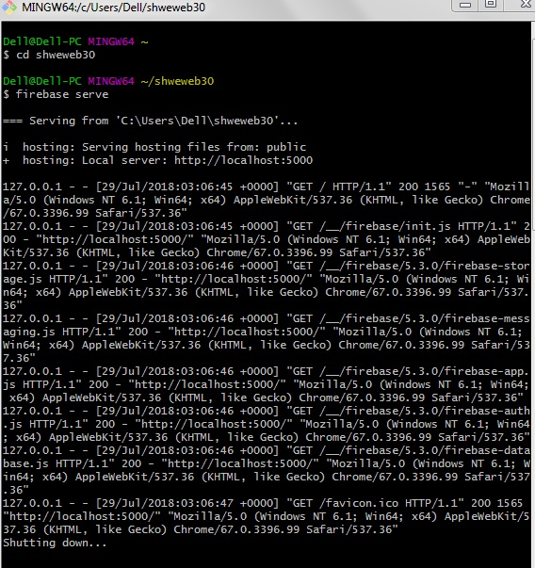

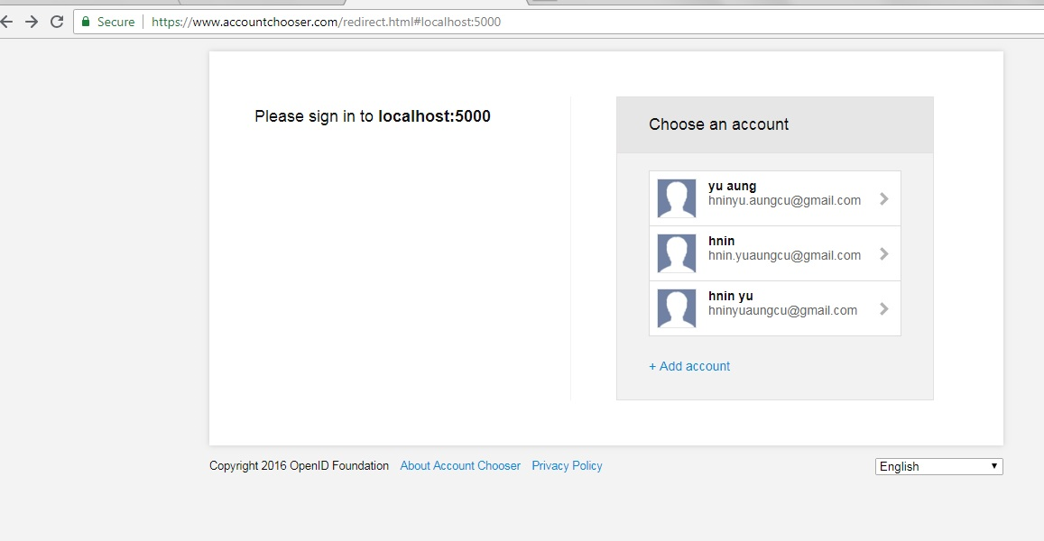

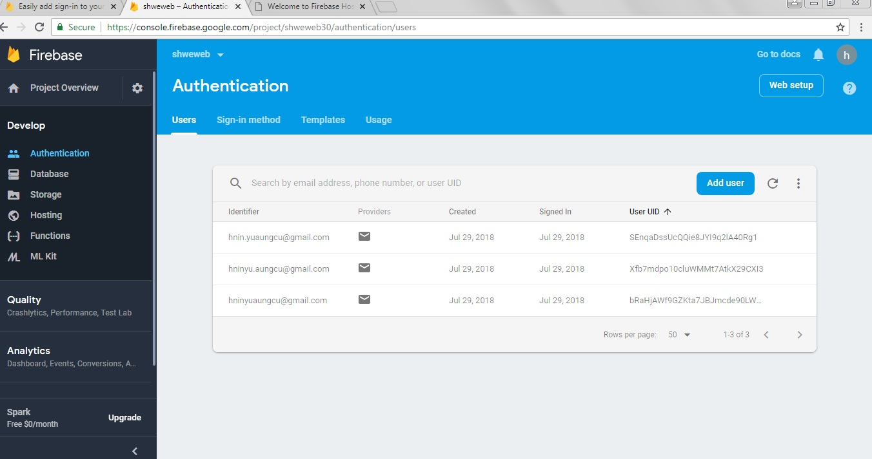

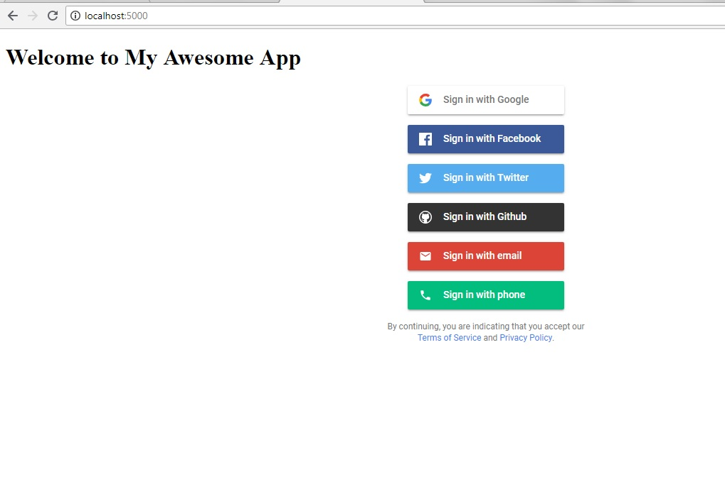

* 1. **Objective of the project**
* To search apps information with these application
* To reduce users time
* To reduce people physical economic
* To develop the apps information in Myanmar
* To reduce the paper work
* To understand the user about apps information without confusing

**Chapter 2**

**Project Development**

2.1 **Design**

**Chapter 3**

**Evaluation and Conclusion**

**3.1 Conclusion**

The system provides simple and complete functions for users without wasting their time. If you have computer with Internet, these application can indicate how to find the apps in Myanmar with a few seconds. “The Apps in Myanmar” application is one part of the improving web development in Myanmar. Our application can satisfy users about searching of the apps information.

**3.2 Advantages of the project**

* Using this system, user will be known the courses without time consuming
* Admin can modify the system dramatically as much as they want
* By using this system, the user can easily search the top application in Myanmar

**3.3 Disadvantages of the project**

* In this system, the user cannot insert, delete and update the data except the admin
* Users cannot search apps in the whole world because we implemented by using apps in Myanmar